AN1292 Demonstration ReadMe for the  
dsPICDEM™ dsPIC33EDV64MC205 Development Board (MPLAB® X IDE)

1. Introduction

This document describes the setup requirements for running the Sensor-less FOC algorithm with a PLL Estimator, which is referenced in AN1292 “*Sensorless Field Oriented Control (FOC) for a* *Permanent Magnet Synchronous Motor (PMSM) Using a PLL Estimator and Field Weakening (FW)”* using a dsPICDEM™ dsPIC33EDV64MC205 Motor Control Development Board.

1. Suggested Demonstration Requirements
   1. Motor Control Application Firmware Required for the Demonstration

* AN1292_dsPIC33EDV64MC205_MotorControl_Development_Board.zip

**Note:**

In this document, hereinafter this firmware package is referred as firmware**.**

* 1. Software Tools Used for Testing the firmware
* MPLAB® X IDE v5.20 or later
* MPLAB® XC16 Compiler v1.36b or later
* MPLAB® X IDE Plugin: X2C-Scope v1.2.3 or later

**Note:**

The software used for testing the firmware prior to release is listed above. It is recommended to use the version listed above or later versions for building the firmware.

* 1. Hardware Tools Required for the Demonstration
* dsPICDEM™ dsPIC33EDV64MC205 Motor Control Development Board (DM330027)
* 24V Power Supply (AC002013)
* 24V 3-Phase Brushless DC Motor (AC300020)
* Microchip Programmer tool - MPLAB® REAL ICE™ In-Circuit Emulator (DV244005).

**Note:**

All items listed under this section Hardware Tools Required for the Demonstration are available at [microchip DIRECT](http://www.microchipdirect.com/).

1. Hardware Setup

This section describes hardware setup required for the demonstration. Motor phase current feedbacks needed by the firmware are amplified by the operational amplifiers that are internal to the dsPIC33EDV64MC205.

1. Disconnect power to the dsPICDEM™ dsPIC33EDV64MC205 Motor Control Development Board.
2. Connect the three phase wires from the motor to PHA, PHB and PHC terminals of connector J7(there is no specific order), provided on the dsPICDEM™ dsPIC33EDV64MC205 Motor Control Development Board.

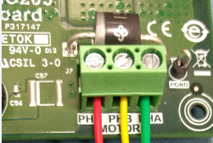

1. 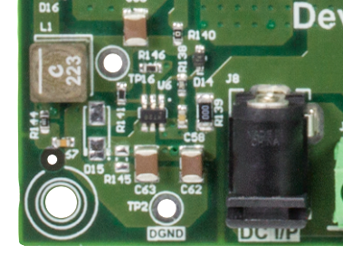Connect a 24V power supply to the dsPIC33EDV64MC205 Development Board, using the J8 connector. Alternatively, 24VDC can be supplied through connector J9. Please ensure the polarity of the supply is matching as indicated.
2. Connect the Microchip programmer/debugger REAL ICE™ In-Circuit Emulator to the Connector J2 of the dsPICDEM™ DSPIC33EDV64MC205 Motor Control Development Board



1. Software Setup and Run
   1. Setup: MPLAB X IDE and MPLAB XC16 Compiler

Install MPLAB X IDE and MPLAB XC16 Compiler versions that support the device dsPIC33EDV64MC205. The version of the MPLAB X IDE, MPLAB XC16 Compiler and X2C-Scope plug-in used for testing the firmware are mentioned in the section Motor Control Application Firmware Required for the Demonstration. To get help on

* MPLAB X IDE installation, refer [link](http://microchipdeveloper.com/mplabx:installation)
* MPLAB XC16 Compiler installation steps, refer [link](http://microchipdeveloper.com/xc16:installation)

If MPLAB IDE v8 or earlier is already installed on your computer, then run the MPLAB driver switcher (It is installed when MPLAB®X IDE is installed) to switch from MPLAB IDE v8 drivers to MPLAB X IDE drivers. If you have Windows 7 or 8, you must run MPLAB driver switcher in ‘Administrator Mode’. To run the Device Driver Switcher GUI application as administrator, right click on the executable (or desktop icon) and select ‘Run as Administrator’. For additional details refer MPLAB X IDE help topic *“Before You Begin: Install the USB Device Drivers (For Hardware Tools): USB Driver Installation for Windows Operating Systems”.*

* 1. Setup: X2C - SCOPE

X2C - SCOPE is a MPLAB X IDE plugin that allows a developer to interact with an application while the application program is running. X2C-Scope enables you to read, write, and plot global variables (for motor control) in real time. It communicates with the target using the UART. To use X2C, the plugin must be installed:

* In MPLAB X IDE, select Tools>Plugins and click on the **Available Plugins** tab.
* Select X2C - SCOPE plug-in by checking its check box, and then click **Install**.
* Look for tool X2C - SCOPE under Tools>Embedded. 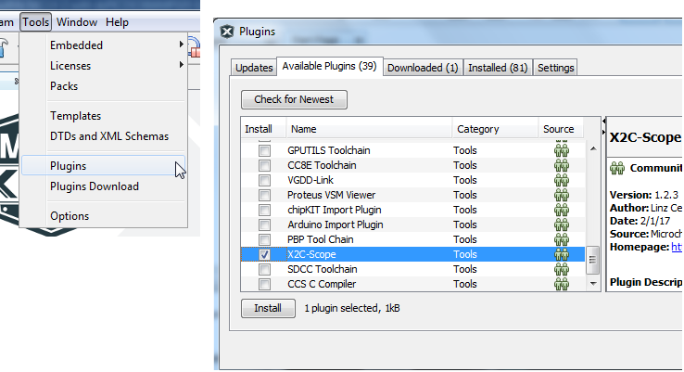

1. Basic Demonstration
   1. Firmware Description

The firmware version required for the demonstration is mentioned under the section Motor Control Application Firmware Required for the Demonstration.

This firmware is implemented to work on Microchip’s 16-bit Digital signal controller (dsPIC® DSC) dsPIC33EDV64MC205**.** For more information, see the *dsPIC33EDV64MC205 Family datasheet (DS70005292)*.

The Motor Control Demo application uses push button to start or stop the motor and potentiometer to vary speed of the motor.

This Motor Control Demo Application configures and uses peripherals like PWM, ADC, Op Amp, UART etc. required for implementing Sensor-less Field Oriented Control (FOC) of Permanent Magnet Synchronous Motor (PMSM) based on the motor control application AN1292.

For more details refer Microchip Application note AN1292 *“Sensorless Field Oriented Control(FOC) for a Permanent Magnet Synchronous Motor(PMSM) using a PLL Estimator and Field Weakening(FW)”* available at [Microchip web site](http://www.microchip.com/)

**Note:**

The project may not build correctly in Windows OS if Maximum path length of any source file in the project is more than 260 characters. In case absolute path is exceeding or nearing maximum length, do any (or both) of the following:

* Shorten the name of the directory containing the firmware used in this demonstration. In this case, rename directoryAN1292_dsPIC33EDV64MC205_MotorControl_Development_Board to more appropriate shorter name. In case you renamed the directory, consider the new name while reading instructions provided in the upcoming sections of the document.
* Place firmware in a location, such that absolute path length of each file included in the projects does not exceed the Maximum Path length specified.

For details, refer MPLAB X IDE help topic *“Path, File and Folder Name Restrictions”.*

* 1. Basic Demonstration

Follow below instructions step by step to setup and run the motor control demo application:

1. Start MPLAB X IDE and open (File>Open Project) the project *pmsm.X*(..*\AN1292_dsPIC33EDV64MC205_MotorControl_Development_Board\pmsm.X*) with device selection *dsPIC33EDV64MC205*.

1. Set the project *pmsm.X* as main project by right clicking on the project name and selecting “Set as Main Project” as shown. The project “pmsm” will then appear in **bold**.

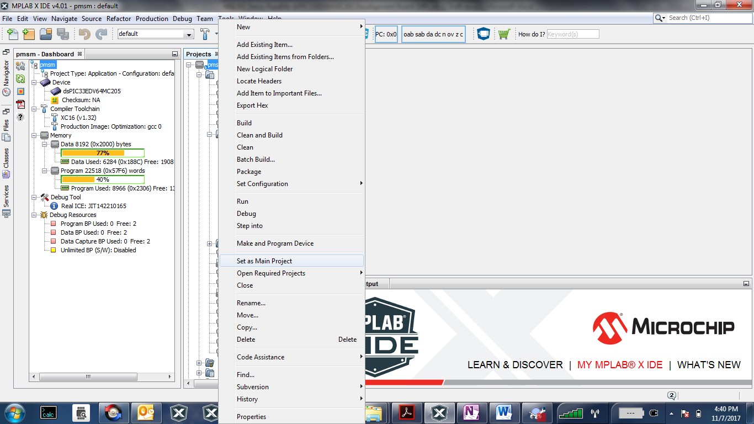

1. Open userparams.h (under pmsm.X -> headerfiles) in the project pmsm.X and ensure that TUNING, OPEN_LOOP_FUNCTIONING, and TORQUE_MODE are not defined.
2. Right click on the project *pmsm.X* and select “Properties” to open its Project Properties Dialog. Click the “Conf: [default]” category to reveal the general project configuration information.

In the *‘****Conf-default’*** category window:

* Select the specific Compiler Toolchain from the available list of compilers. Please ensure MPLAB® XC16 Compiler supports the device dsPIC33EDV64MC205.In this case “XC16(v1.36)” is selected. The compiler used for testing the firmware is listed in the section 2.2 Software Tools Used for Testing the firmware.
* Select the Hardware Tool to be used for programming and debugging. In this case, “Real ICE” is the selected programmer.
* After selecting Hardware Tool and Compiler Toolchain, click button **Apply**

1. To build the project (in this case *pmsm.X*) and program the device dsPIC33EDV64MC205, click “**Make and Program Device Main project**” on the toolbar.

1. Run or Stop the motor by pressing the push button **SW1**. The function of the pushbutton **SW1** (Run/Stop of the motor) is indicated by turning ON or OFF the **LED LD1**.

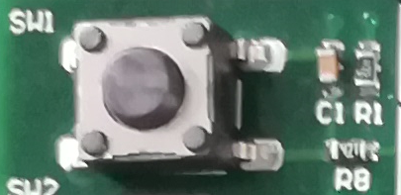

1. If desired, the motor speed can be varied using the potentiometer (labeled R43).

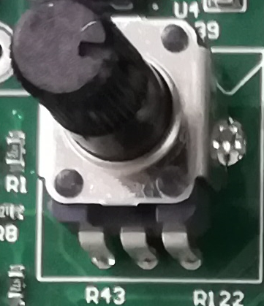

1. To enter the extended speed range (NOMINAL_SPEED_RPM to MAXIMUM_SPEED_RPM) press the push button **SW2**. Press the push button **SW2** again to revert the speed of the motor to its normal speed (END_SPEED_RPM to NOMINAL_SPEED_RPM) range.

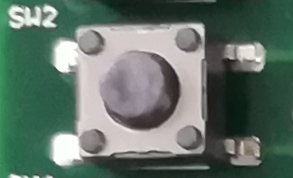

1. Press the push button **SW2** to stop the motor.

**Note:**

The macro definitions END_SPEED_RPM, NOMINAL_SPEED_RPM, and MAXIMUM_SPEED_RPM are specified in userparms.h file included in the project *pmsm.X*. The definitions NOMINAL_SPEED_RPM, and MAXIMUM_SPEED_RPM are defined as per the specification provided by the Motor manufacturer. *Exceeding manufacture specification may lead to damage of the motor or(and) the board.*

* 1. Data visualization through X2CScope Plug-in of MPLABX

The application firmware comes with initialization required to interface Controller with Host PC to enable Data visualization through X2C Scope plug-in. X2C-Scope is a third-party plugin for MPLAB X which facilitates real-time diagnostics.

1. Ensure X2C Scope Plug-in is installed. For additional information on how to set up a plug-in refer <https://microchipdeveloper.com/mplabx:tools-plugins-available>
2. To utilize X2C communication for this demonstration, a mini-USB connection is required between Host PC and dsPICDEM™ DSPIC33EDV64MC205 Motor Control Development Board. Connect a mini-USB cable from your computer to the J8 connector of the dsPICDEM™ DSPIC33EDV64MC205 Motor Control Development Board.

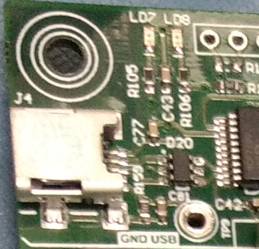

1. Ensure application is configured and running as described under Section Basic Demonstration by following steps 1 through 9.
2. 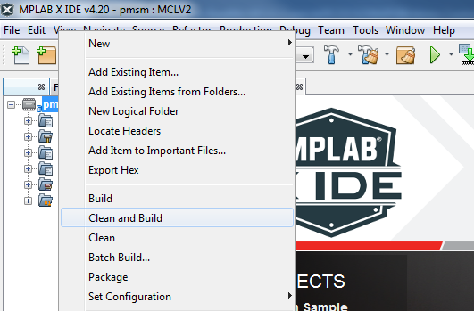Build the project *pmsm.X*. To do that right click on the project *pmsm.X* and select “Clean and Build”.
3. Please ensure that the checkbox “Load symbols when programming or building for production (slows process)” is checked, which is under the “Loading” category of the Project Properties window.

1. To build the project (in this case *pmsm.X*) and program the device dsPIC33EDV64MC205, click “**Make and Program Device Main project**” on the toolbar.

1. Open the X2C window by selecting Tools>Embedded>X2CScope.

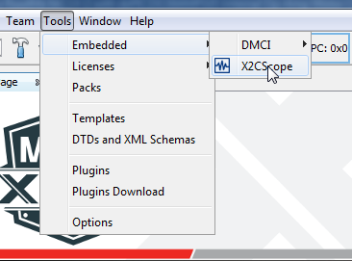

1. In the X2CScope Configuration window, using “Select project” menu, select pmsm.X project as shown.

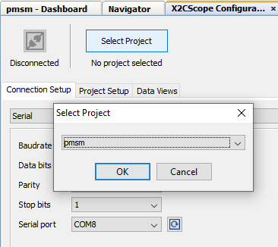

1. Remote Communication needs to be established, as indicated in the following figure. Ensure the communication baud rate is set to 115200 as the same is set in the application firmware, while COM port used depends on the system settings. Refresh button lists the available COM Ports. Select the COM Port as per the connection.

1. Once COM port is detected, click on “**Disconnected**”, and it will turn to “**Connected**”, if the link is established as programmed.

1. Set the “Project Setup” as shown below and click “Set Values”. Set Scope sample time as interval at which X2CScopeUpdate() is called. In this application it is every 20kHz (50µs).

1. When the setup is established, click on Open Scope View (under sub window “Data Views”), this open Scope Window.

1. In this window, select the variables that needs to be monitored. To do this, click on the source against each channel, a window Select Variables opens upon the screen. From the available list, the required variable can be chosen. Ensure check boxes Enable & Visible are checked for the variables to be plotted.

To view data plots continuously, uncheck Single-shot. When Single-shot is checked it captures the data once and stops. The Sample time factor value multiplied with Sample time determines the time difference between any two consecutive data points on the plot.

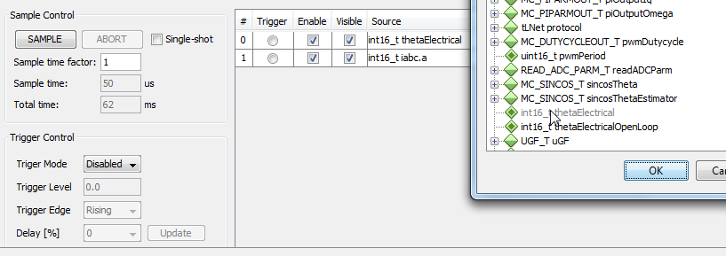

1. Click on SAMPLE, then X2C scope window shows variables in real time, which is updated automatically.

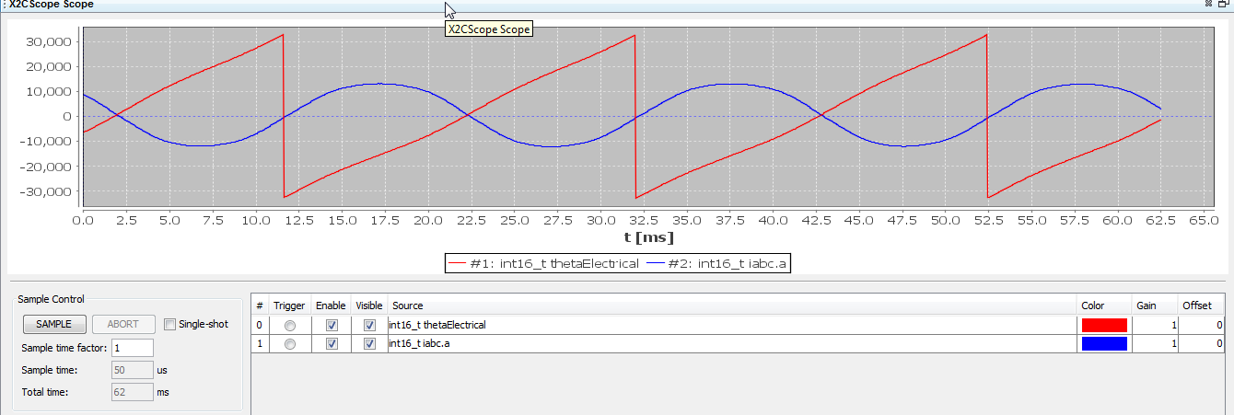

1. Click on ABORT to stop.

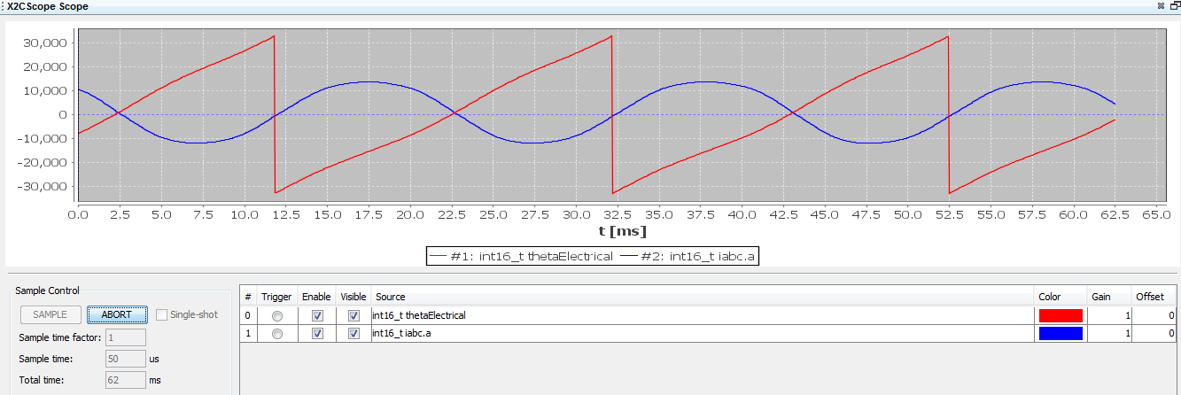

1. REFERENCES:

For additional information, refer following documents or links.

1. AN1292 Application Note “Sensorless Field Oriented Control (FOC) for a Permanent Magnet Synchronous Motor (PMSM) Using a PLL Estimator and Field Weakening (FW)”
2. dsPICDEM™ DSPIC33EDV64MC205 Motor Control Development Board User’s Guide (DS50002883)
3. dsPIC33EDV64MC205 Family datasheet (DS70005292).
4. Family Reference manuals (FRM) of dsPIC33EDV64MC205 family
5. MPLAB® X IDE User’s Guide (DS50002027) or MPLAB® X IDE help
6. [MPLAB® X IDE installation](http://microchipdeveloper.com/mplabx:installation)
7. [MPLAB® XC16 Compiler installation](http://microchipdeveloper.com/xc16:installation)